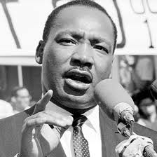
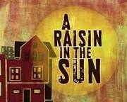
A Raisin in the Sun meets Dr. Martin Luther King, Jr.
Comparison Essay Rubric
60 points

_________ Notes: 5 points

5 points

_________ You have a strong thesis, with the similarities that outline the overall organization of your paper.

Comments:

24 points
_________ You use at least one concrete example from the play and one concrete example from the speech to give evidence for EACH of your similarities.

Comments:

6 points

_______ You clearly explain why your examples give evidence of the similarity discussed.

10 points (-2)

________ You use complete sentences throughout the entire paper.

Comments:

10 points

________ 1-2 Minute Speech Using the Following Guidelines:

_____ Looked at audience
_____ Prepared (not read)
_____ Voice is projected
_____ Body Control (not too fidgety, standing up straight, etc.)
_____ Made Clear Points (identified an example for each similarity from both the play and the speech)

